Stakeholder Engagement Plan

# 1. Purpose

This plan ensures consistent, effective communication and collaboration with all key stakeholders involved in the HealthFirst Care project. It aligns with the BRD, RTM, and stakeholder priorities to promote transparency, trust, and project success.

# 2. Stakeholder Matrix

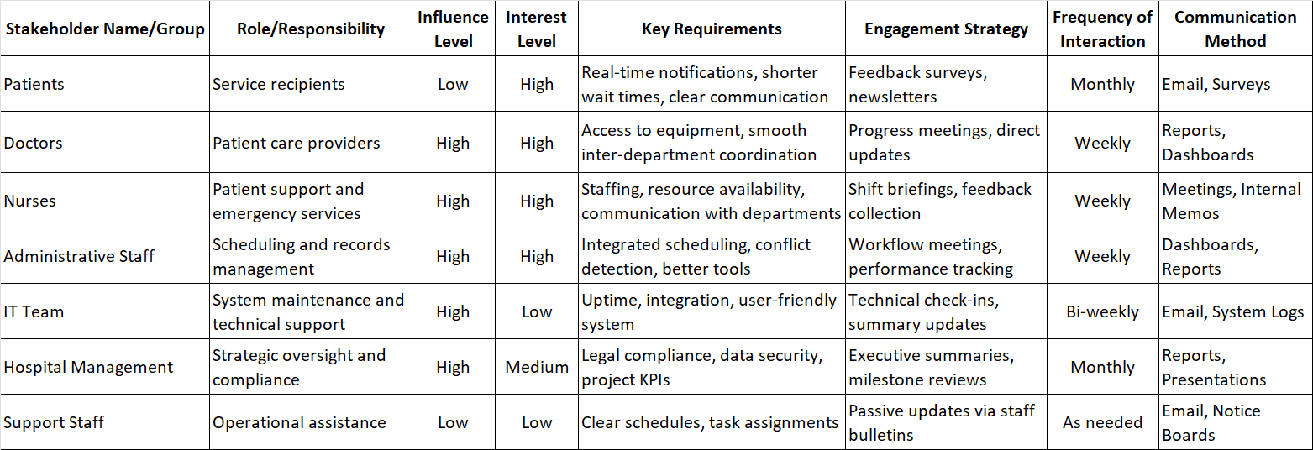

# 3. Objectives of Engagement

* Patients – Improve service delivery through feedback and timely communication.
* Doctors & Nurses – Ensure their concerns about resources and processes are addressed.
* Administrative Staff – Involve them in testing and validating scheduling tools.
* IT Teams – Keep them updated on infrastructure and feature requirements.
* Management – Keep them informed on KPIs, risks, and project alignment.
* Support Staff – Ensure they are informed of operational changes when needed.

# 4. Tools & Channels

* Project dashboards
* Meeting summaries and minutes
* Progress reports and performance scorecards
* Surveys and feedback forms

# 5. Alignment with BRD & RTM

All engagement strategies are built to support key project objectives such as reduced wait times, better communication, and efficient resource utilization.

The plan reflects stakeholder needs and expectations as outlined in the BRD and validated through the RTM.